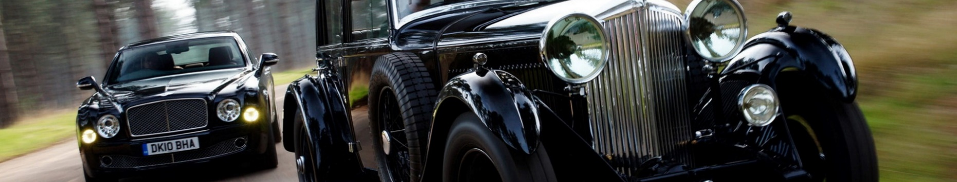
AUTOMOBILES
All of those cars were once just a dream in somebody’s head*

*Peter Gabriel, Mercy Street
Grammar:
-ing and –ed adjectives
Participle clauses
Absolute participle clause

Word formation:
Word blends

Reading:
Inventor of automobile.
5 cutting-edge features you don’t want in your new car.
Mercedes F 015
Future car trends
Self-driving cars
Flying cars
Cars that communicate with the road and with each other

Listening:
Top 5 car safety features
Correct pronunciation of car brands
The future of cars

Video:
How we invented the world: cars
Mercedes F 015

Writing:
Paragraph

Essential vocabulary

accelerate, v boast, v emit, v outfit, v reverse, adj steer. v
accommodate, v collision, n engine, n/ power, v revise, v subject, v
adjust, v combustion, n execution, n prevent, v rotate, v vehicle, n
annoy, v cutting-edge, adj infotainment, n propel, v shift, n warning, n
avoid, v draw, v mandatory, adj receive, v steam, n wear, n

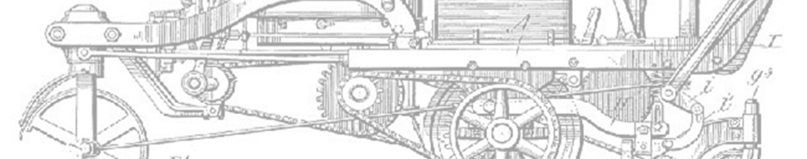
Module 7 Lesson 1
Car, I am your father

1. What is special about these cars? Discuss in small groups
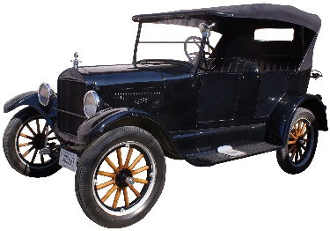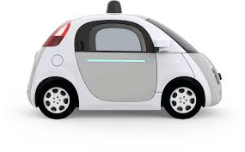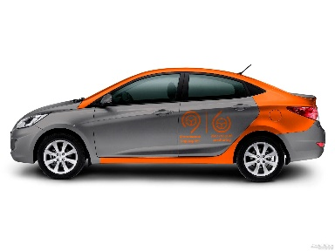
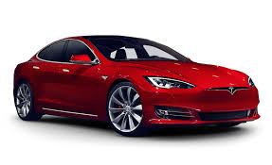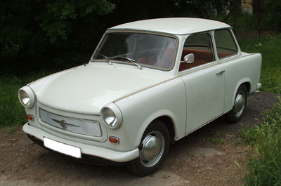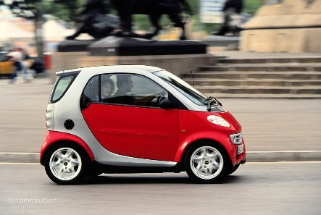

WHO INVENTED THE FIRST CAR?
2 Look at some of the candidates for the Father of Automobile title. Do any of the names seem familiar to you?
Leonardo da Vinci [liːəˈnɑːdəʊ dɑː ˈvɪnʧi]
Ferdinand Verbiest [ˈfɜːd(ə)nænd vərˈbɪst]
Nicolas-Joseph Cugnot [nikɔˈlas ʒɔˈzɛf kuˈŋɔ:]
Gottlieb Daimler [ˈgɒtlɪb ˈdaɪmlə]
Wilhelm Maybach [wɪlˈhɛlm ˈmeɪbək]
3 Look through the text and match the words in bold to their Russian equivalents.
____________ груз
____________ двигатель внутреннего сгорания
____________ дюйм (2,54 cм)
____________ на конной тяге (гужевой)
____________ на паровой тяге
____________ рулевая колонка
____________ самоходный
____________ транспортное средство
____________ четырехтактный двигатель

4 Read the texts and in pairs decide who deserves to be called the father of automobile.
Present your opinion to the group.

a. Leonardo da Vinci
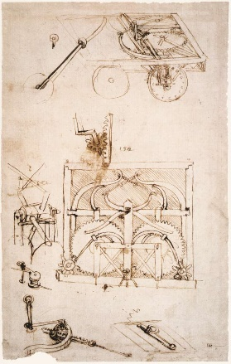
In 1478, more than 500 years ago, Leonardo da Vinci created a design for the first self-propelled vehicle, or "automobile." As far as we know, no working prototype was ever built from da Vinci's plans. The car invented by da Vinci was meant more to stimulate wonder than move people and things from one place to another. This vehicle was designed to be 5 feet and 6 inches long and 4 feet and 11 inches wide. It didn’t even have a seat and could only turn right!

b. Ferdinand Verbiest
The first working self-propelled vehicle was created in 1672 by Ferdinand Verbeist (a Jesuit missionary) as a toy for the Chinese Emperor. Being just over two feet long, the steam-powered vehicle was not designed to carry cargo or people. Although it was too small for anyone to actually be able to sit in, the vehicle is believed to be the very first working steam-powered vehicle.

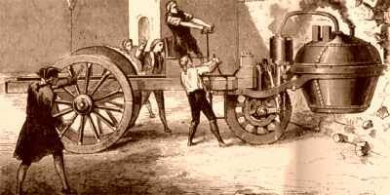
c. Nicolas-Joseph Cugnot
In 1770, French inventor Nicolas Cugnot created a larger steam-powered, self-propelled car, called the "Fardier." Adapted from a horse-drawn vehicle, the three-wheeled car supported a massive steam boiler and travelled at about two miles per hour.
https://www.youtube.com/watch?v=KP_oQHYmdRs

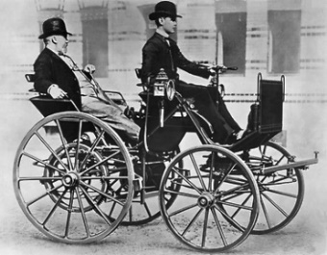
d. Gottlieb Daimler and Wilhelm Maybach
In 1886 Daimler and Maybach created the “Cannstatt-Daimler” which was the first four-stroke engine, four-wheeled vehicle and another candidate for the first car. It was a gift for Daimler’s wife. The car was able to reach 16 kilometers per hour.

e. Karl Benz
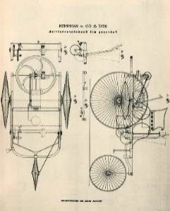
In 1886, Carl Benz received a patent for the three-wheeled "Motorwagen," he began selling the vehicles three years later. The Motorwagen ran on an internal combustion engine, had a steering column, and had a seat for the driver and one or two passengers. Benz continued to revise the design, and in 1893, the Motorwagen received a fourth wheel.
5 Read the text again and put the numbers of the fragments next to the descriptions.

- These vehicles had three wheels: __3__ and ___.
- This car design was never put to practice: _____ .
- These vehicles were powered by steam: ____ and ____ .
- These vehicles had internal combustion engines: ____ and ____.

6 In pairs discuss the questions below:

  - Do you know any other names in the automotive history?
  - Who should be considered the real inventor: someone who came up the idea or the person who put it into practice?
  - Why does it happen sometimes that there is more than one person claiming to be the first to invent something?

7 Match the verbs with their Russian equivalents.

- draw a) достигать
- power b) поворачивать
- propel c) управлять рулем, направлять
- reach d) пересматривать
- revise e) служить источником энергии
- steer f) тянуть, притягивать
- turn g) продвигать вперед, приводить в движение

8 Fill in the gaps with the verbs from Ex. 7.

  - Only about 20 percent of the energy within the gasoline is actually used to ______ the car.
  - Move the joystick left or right to ______ the helicopter.
  - The students had to ______ their truck's design to achieve high-performing results.
  - _______ the moon within the decade. – this was the mission given to NASA in the 1960s.
  - Good teachers try to _______ students into discussions.
  - A combustion engine and a hydraulic motor work together to ______ the Hybrid Air car.
  - In many cities, horse-______ carriages are seen as tourist attractions – but this is a cruel industry.
  - Never _______ the steering wheel while the vehicle is stationary.

9 *Match the words derived from PROPEL with their Russian equivalents.

Word Root of propel
The Latin word pellere, meaning “to cause to move” or “to drive,” gives us the root pel. Words from the Latin pellere have something to do with driving or causing something to move.
To propel is to drive forward.
To compel is to drive someone to do something.
To expel is to drive out.
To repel is to drive back or away.

propulsion A. движущая сила
propellant B. ракетное топливо
propeller C. устройство в виде нескольких закреплённых на вращающейся оси лопастей для приведения в движение самолётов, судов и других транспортных средств
D. метательное взрывчатое вещество

GRAMMAR: -ING AND –ED ADJECTIVES
Adjectives ending in –ing have an active meaning. They describe:
    - someone or something that is doing something (acting);
    - someone or something that is causing some feeling or emotion
    - an ongoing process
Examples: a hard-working specialist; a self-driving car; a depressing thought; an interesting project; a developing country
Adjectives ending in –ed (or irregular past participle form) have a passive meaning. They describe:
    - someone or something 'receiving' some kind of action,
    - someone made to feel in a certain way or given an impression.
    - a complete process
Examples: a human-driven car; reinforced concrete; a depressed teacher, a developed country; a finished project

10 Find examples of –ing and -ed adjectives in the text.

-ing | -ed

11 Transform the structures below according to the pattern.
  - The car that is powered by steam = steam-powered car
  - The vehicle that is drawn by a horse =
  - The vehicle that is powered by gas =
  - The toy that is powered by a battery =
  - The invention that has long been forgotten =
  - The accessory that was made by hand =
  - The automobile that is produced in mass quantities =

  - The wheel you can steer with = steering wheel
  - The space you can park in =
  - The license that allows you to drive =
  - The parts that are able to move =
  - The car that can fly =
  - The ticket issued for excessive speed =
  - The technology that is meant to save energy =
  - The device that helps save fuel =

12 *Find the English equivalents to the word combinations below.

Самоходное транспортное средство; штраф за превышение скорости; водительское удостоверение; автомобиль, работающий на газе; бензиновый автомобиль; рулевое колесо; автомобиль массового производства; парковочное пространство; гужевой транспорт; энергосберегающие технологии.

13 Watch the video HOW WE INVENTED THE WORLD: THE BENZ CARS and decide whether the following statements are True or False. Correct the false statements.
- Karl Benz invented the horseless carriage at the age of 15.
- Karl Benz was a brilliant engineer but had very poor business skills.
- The Patent Motor-Wagen he was working on in 1888 could go in reverse (= backwards).
- Bertha Benz supported her husband morally and financially.
- An automotive vehicle was considered to be against the God and the state.
- Karl Benz was too ill to present his invention to the public.

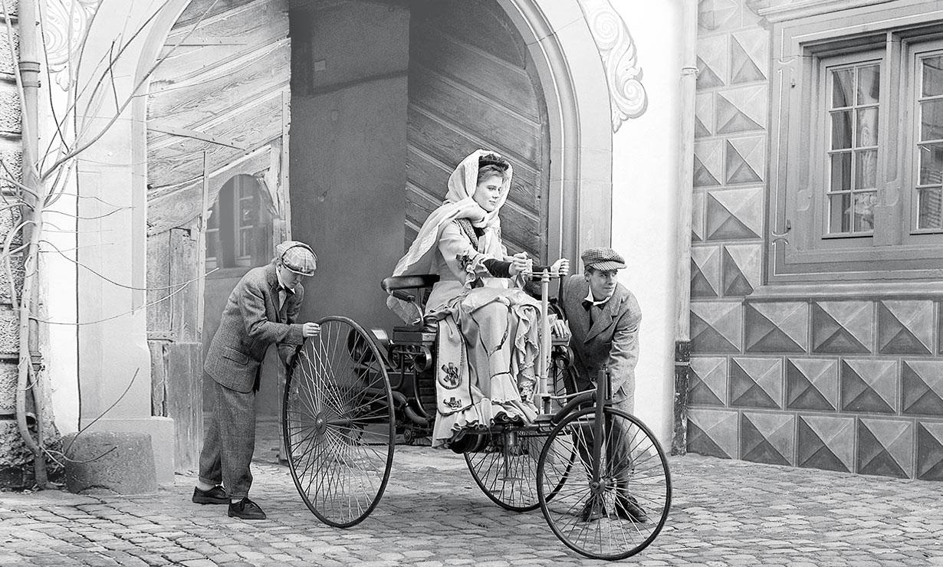
Bertha Benz driving the Benz Patent Motor Car, 1886

14 Choose the appropriate adjective.

Karl Benz was a determining/ determined and talented inventor. He had always dreamt about creating a self-propelling/ self-propelled vehicle. The patenting/ patented motor car was ready to appear in public. However, the country was not interesting/ interested. Benz felt depressing/ depressed and frustrating/ frustrated. Fortunately, his wife Bertha was a risk- taking/ risk-taken woman. This daring/ dared lady did not wait for her husband to pick up his courage and present this long-expecting/ long-expected invention. Bertha Benz went on an exciting/ excited 65 miles’ journey all by herself to advertise the car.

15 *Fact or fiction? Make your guess and google to check it.

- There are one billion cars currently in use on Earth.
- The man who invented the cruise control could not see.
- In 1941 Ford manufactured a car from beans.
- In 1916 more than half of all the cars in the world were Model T Fords.
- A car spends 95% of its lifetime parked.
- In the beginning of the 20th century horses produced more pollution than cars.
- The driver that got the world’s first speeding ticket was going 19 kph (kilometres per hour)

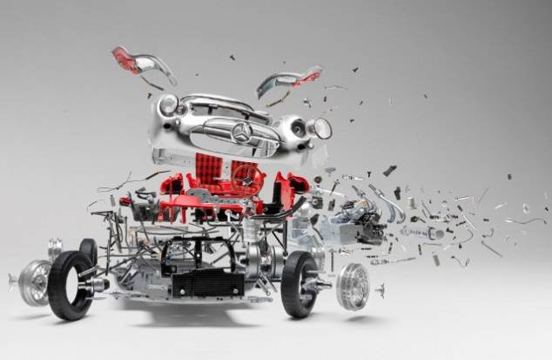
Module 7 Lesson 2
Car anatomy
Foto by Fabian Oefner

16 In each of the groups choose the odd word out.
0  car  automobile  machine | 1  engine  engineer  motor | 2  liquid  propellant  fuel | 3  steam  vapour  smoke | 4  to turn  to draw  to pull | 5  to propel  to push  to reach | 6  inch  gram  second | 7  pound  inch  foot

17 What car parts are those? (See Vocabulary appendix)
- It shows you how fast you are going.
- You step on it if you want to slow down.
- You press it when you want to go faster.
- You turn them on when it starts to rain.
- You use them to see what’s around you on the road.
- You turn all these off when you’ve finished your trip.
- You roll it down when you approach a toll booth.
- You use these to communicate with other cars on the road.
- You open it if you want to look at your engine.
- You press this pedal if your car has manual gearbox (manual transmission).
- These protect you in road accidents.

18 *Describe the functions of these car parts.
Glove box; license plate, visor, gearshift, parking brake, fuel gauge, headlight

19 Answer these questions in pairs.
1. What car parts have survived since the early days of the automobile history?
2. What car parts are going to disappear soon?
3. What car parts will still be present in automobiles 50 years from now?

20 Find the English equivalents to the word combinations.

Капот; бардачок; дворники; бензобак, шина; подголовник; приборная панель; фары; поворотник; номерной знак; ручной тормоз; коробка скоростей

GRAMMAR

PARTICIPLE FORMS |  | Active | Passive
Participle I/  Present Participle/  -ing form | Simple | driving// powering | being driven// being powered
Participle I/  Present Participle/  -ing form | Perfect | having driven  having powered | having been driven  having been powered
Participle II/ Past Participle/  -ed form |  | —————- | driven// powered

21 Provide participle forms for the following verbs:

Steer, draw, build, collide, fit; turn; reach.

22 Choose the suitable English translation
- При движении задним ходом, поворачивайте руль в противоположном направлении. Driven/ Driving in reverse, you should steer in the opposite direction.
- Выиграв чемпионат, гонщик решил завершить свою карьеру. Having won / Being won the championship, the racer decided to finish his career.
- Ослепленный солнцем, водитель не увидел пешехода. Blinded/ Having blinded by the sun, the driver didn’t see the pedestrian.
- Припарковав машину, мы стали искать паркомат. Having parked/ Parking the car, we started looking for a parking meter.
- Машина Фардье, приводимая в движение паром, могла проходить 2 мили в час. Fardier, being powered / having been powered by steam, could reach 2 miles per hour.
- При покупке автомобиля, бывшего в употреблении, убедитесь, что он не побывал в аварии. After buying/ When buying a used car, make sure it hasn't been in a crash.
- Поворачивая налево, уступите дорогу встречным ТС, двигающимся прямо. Turning left/ Being turned left, give way to oncoming vehicles having gone/ going straight.
- Пробыв за рулем 8 часов, дальнобойщик начал клевать носом. Having driven/ Driving for 8 hours, the trucker started feeling drowsy.
- Находясь за рулем 8 часов, дальнобойщик начал клевать носом. Having driven/ Driving for 8 hours, the trucker started feeling drowsy.

23 Complete the sentences with the participle clauses.

- Verbiest’s vehicle was too small. It was used as a toy. [BEING]
Being too small, Verbiest’s vehicle was used as a toy.
- After Karl Benz received a patent, he could begin selling his cars. [RECEIVING]
- After Karl Benz received a patent, he could begin selling his cars. [HAVING]
- My friend drove my car and got a speeding ticket. [DRIVING]
- The first steam-powered vehicle was built in the 18th century, it was reproduced in 2010. [HAVING]
24 *Transform the sentences so that each of them contains a participle clause.
- Introduce/ Henry Ford/ 1908, the Model T became a big success.
- After/ install the moving assembly lines/ in factory/1913, Ford became the biggest car manufacturer in the world.
- Reduce/ production time, the assembly line lowered manufacture costs for cars.
- Hold/ patent on a "road engine", George B. Selden was paid royalties (percentage of the income) by all American car manufacturers.
- Ford opened the American car market for inexpensive car overturn/ Selden/ patent.

LISTENING: CAR SAFETY FEATURES

25 Work in pairs and make a list of car safety features.

 | Active safety | Passive safety
Mandatory features
(required in all cars)
Optional features

26 Listen and compare with your ideas.

27 Match the safety benefits to the car safety features from Ex.26.

a) The most important automobile safety feature is _______ .
b) Daytime running _________ increase visibility and reduce daytime crashes.
c) _______ __________eliminate swerving and skidding problem.
d) In the US, _______ became mandatory standard equipment in 1998.

28 Which of these features does your car have? Match each to its Russian equivalent. Rank them in order of importance.
 | - lane-departure warning | - система «старт-стоп»
 | - blind spot monitoring | - мультимедийные экраны
 | - back-up assist | - система контроля мертвых зон
 | - automatic start/stop | - электронное зеркало заднего вида
 | - forward collision warning | - система предупреждения при движении задним ходом
 | - automatic braking | - система слежения за дорожной разметкой
 | - infotainment screens | - система предупреждения о возможном столкновении
 | - digital rearview mirror | - автоматическое торможение
29 Read the paragraphs below and match them to the automobile features names and the pictures. Note! There is one extra picture and one title that you don’t need.

Digital rearview mirror
Haptic (= tactile) interface
Automatic start/stop
Advanced warning systems
Automatic braking
Back-up assist

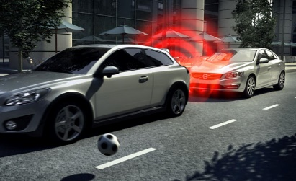  a | 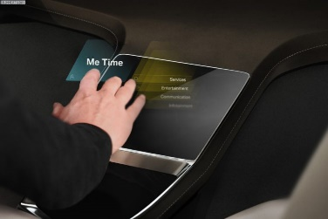/  b | 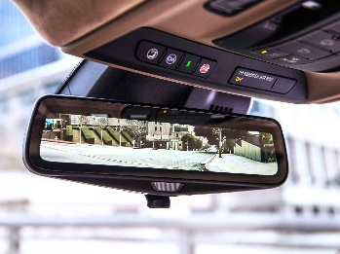  c
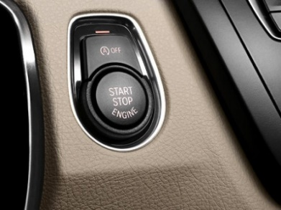  d | 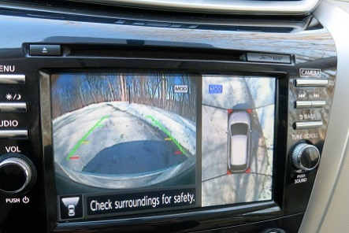  e | 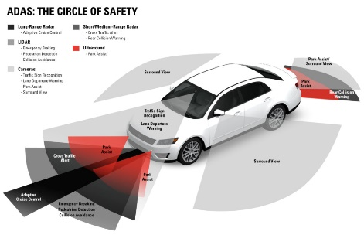  f

5 CUTTING-EDGE FEATURES YOU DON’T WANT IN YOUR NEW CAR
James Derek Sapienza

cutting-edge современный
subject, v подвергать
prevent предотвращать
outfit, v оборудовать
collision столкновение
warning предупреждение
latter последний (из двух)
annoying раздражающий
rotating вращающийся
adjust настроить(ся), перестроить(ся)
shift сдвиг,
execution исполнение

1. d Automatic start/ stop
In theory this is a pretty good idea: Turning off your car during prolonged traffic stops really eliminates unnecessary idling. But when in stop and go traffic, or just cruising around downtown, this fuel saving switch can turn into Chinese water torture, as the vehicle starts and stops itself at a moment’s notice. Yes, it can make a difference at the pump, but we don’t like the idea of subjecting one’s starter and battery to unnecessary wear and tear dozens of times a day.
2.
In order to prevent accidents, many automakers have started outfitting their vehicles with forward collision warnings and automatic braking. While it is a great idea, the latter can be a potentially dangerous feature. Imagine the chaos that would follow when a plastic bag flies in front of you and triggers your car’s auto stop function while going 70 down the interstate, causing all four wheels to lock up.

3.
This is a feature that automakers are finally beginning to move away from. Infotainment screens that require touching a mouse pad or a trackball can be more annoying than useful, as they often end up causing more headaches than they’re worth. Overly sensitive and generally unintuitive, these exotic forms of navigation are further proof that a touch screen or rotating command knob is all that you really need these days.
4.
Cadillac debuted this tech a few years ago, and on the surface, it is another pretty good idea. With big crossover and SUV interiors creating a tunnel-like view in your rearview mirror, you can now get a high-definition live stream from your backup camera right into your mirror. But in reality, it’s difficult for your eyes to adjust to the perception shift, and that takes your eyes off the road for a few precious seconds, which is never a good thing. Unfortunately, this innovation is better in concept than execution.
5.
Most new cars are available with a number of electronic safety systems, and for the most part, they are great. You can get lane-departure warning, blind spot monitoring, back up assist; a whole host of things that tell you what’s happening 360 degrees around your car at all times. It’s all well and good, until you’re in a crowded parking lot or trying to parallel park on a city street. Having four different systems screaming at you every time you park is nerve-racking enough, trying to turn all these systems off while you do it is even worse.

30 Read the text again and do the multiple choice exercise.

- The positive aspect of the automatic start/ stop feature is that
  - it protects the engine
  - it saves fuel
  - it saves time
  - it helps navigation

- What is wear and tear in Para 1?
- extra cost
- damage as a result of normal use
- damage from an accident
- fuel consumption

- Automatic braking can be dangerous
  - at high speed
  - in combination with the forward collision warning system
  - for 4-wheel-drive vehicles
  - in the city
- Infortainment screens (Para 3) are …
  - easy to use
  - too smart
  - not very sensitive
  - difficult to use

- What is ‘the perception shift’ in (4)?
  - you need to adjust some screen settings
  - you have difficulty seeing in the dark
  - you start seeing your life with new eyes
  - you see digital images differently

- What is bad about having too many warning systems?
  - they can distract you
  - they cost too much
  - they use too much energy
  - they make the car crowded.

31 Replace the word in italics with an Essential vocabulary item (Ex. 28 ).
- We don’t allow our cars on the road without putting them first to numerous tests.
- Gadgets bring latest technology to old cars.
- Autonomous cars will keep accidents from happening, remove traffic and save lives.
- Some automakers are now equipping cars with WiFi hotspots.
- Regulate your side mirrors to avoid blind spots.
- While crash-free cars are still years away, brake assist is already on the market.
- Swivel car seats, which can turn 360 degrees, are great for getting your baby in and out of the chair easily.
- Millennials are forcing a change in the auto industry.

32 Discuss these questions in pairs.

  - Do you agree with the opinion presented in the text?
  - Can you prove any of the arguments wrong?
  - What car features do you consider useless or dangerous?

33 Wordblends. Try to guess what words are the results of the blends below.

INFORTAINMENT = INFORMATION + ENTERTAINMENT
= BREAKFAST + LUNCH
= WEB + LOG
= CYBERNETIC + ORGANISM
= SMOKE + FOG
= PICTURE + ELEMENT
= BINARY + DIGIT
= MECHANICS + ELECTRONICS
= WEB + SEMINAR
Module 7 Lesson 3
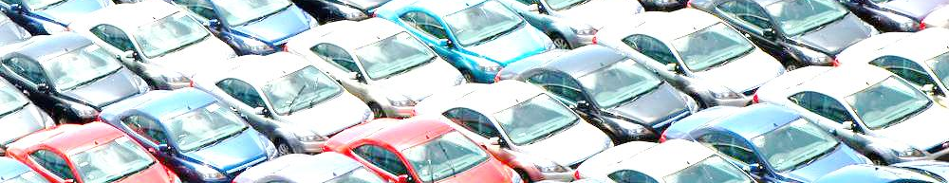
AUTOMOBILES TODAY
Automobiles of today
34 Using the words below, form as many word combinations as you can.

power | parking | space | speeding
driving | turn | steering | license
wheel | automatic | test | ticket
lights | side | braking | mirror

35 Fill in the grid with the car brands you know. Listen and cross out the brands you hear. Three crosses in a straight line: BINGO!

36 In pairs discuss the following questions.

- What brand is your family car (or cars)?
- Which car did you have before this one?
- If you can drive, do you remember your first car?
- Do you have a favourite car make? What is it?
CAR SLOGANS
37 Car companies often use –ing and –ed structures in their slogans. Look at the examples below. Can you guess which car brands are these slogans for?
- Inexpensive. And built to stay that way.
- Creating a higher standard.
- Born to perform.


38 Use the –ing and –ed forms of the given verbs to complete the automobile slogans.

Audi (Keep) ahead through technology
BMW The ultimate (drive) machine
Fiat (Drive) by passion
Fiat Strada Hand-(build) by robots
Ford Better ideas (drive) by you
Ford (Build) for the road ahead
Hyundai (Drive) is (believe)
Kumho Race (prove) performance
Mercedes-Benz (Engineer) to move the human spirit
Montero Sport Perfect for (damage) surfaces
Nissan (Build) for the human race
Pontiac (Design) for action
Toyota (Move) forward
Toyota The best (build) cars in the world
Volkswagen Drivers (want)

39 *Translate these Russian-language slogans into English using the –ing and –ed adjectives

Audi A6 | Игра по своим правилам.
BMW | С удовольствием за рулем
Ford | Надежен. Создан для жизни.
Hyundai Sonata. | Исполнена для Вас.
Infiniti | Опережает время
Volkswagen | Поднимая планку. Снова.

40 *Now you know the rules of the game. Invent your own slogan for the car you drive now or would like to drive someday. Do not forget about the –ing and –ed forms.

41 Watch the video Mercedes F 015. Take notes about the main features of the new car.

teardrop shape каплевидная форма
peril опасность
hump выступ, горб
hinge петля (дверная)
headroom внутренняя высота кузова
- dimensions
- exterior
- interior
- engine type
- automation
- performance characteristics
42 Read the text and mark the parts of the text that contain the information missing from the video.

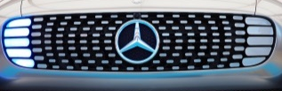
About as big as a new S-Class, the concept is fitted with LED inserts in the grille instead of headlights, a nearly horizontal windshield, 26-inch alloy wheels and rear doors that open at a 90-degree angle. LEDs are integrated into the rear bumper and a small QR code replaces the license plate.
grille
The dashboard has been replaced by a wide touchscreen that displays data such as navigation directions as well as vital information about the car and its surroundings. Similarly, the door panels gave place to high-definition color touchscreens that ensure none of the occupants get bored on long trips.
The F 015 can accommodate four adults on individual leather-upholstered seats. If the car is driving itself, the steering wheel retracts (draws inside) into the dashboard and the front seats can swivel (rotate) 180 degrees, making it possible to hold a meeting or simply relax with friends.
The F 015 accelerates from zero to 62 mph in 6.7 seconds thanks to a hydrogen-electric hybrid drivetrain that generates a total output of 272 horsepower. The sedan boasts a total driving range of over 680 miles while emitting nothing but water vapor.

43 Match the words in bold from Ex. 40 to their synonyms below.

guarantee =
have enough space for =
have (something to be proud of) =
give out =
increase the speed =

44 Fill in the gaps with the verbs from Ex. 43.

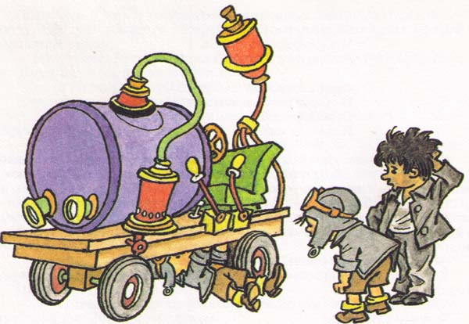
The Bendum and Twistum workshop proudly presents its latest creation – the BT1 Mitesmobile. The BT1 ________ from 0 to 100 thanks to the newest soda-water engine. It _____ nothing but fruit-smelling water vapor and is modified to _______ that no one will get thirsty on long trips. The car also ________ four wheels and some gears and levers. The Mitesmobile is extremely comfortable and can ____________ two (or more) passengers. The Mitesmobile is a huge step forward for tiny people.
Artist: Evgeny Migunov

PARAGRAPH WRITING

A paragraph is a group of sentences dealing with one topic.
A paragraph size in academic writing is usually between five and ten sentences.

45 Study the paragraph structure. Identify the paragraph parts in Ex. 44.

The topic sentence
This is the main idea of the paragraph. It is the most general sentence in the paragraph
The supporting sentences
They are more detailed sentences. Use them to support, develop or explain the idea expressed in the topic sentence.
The concluding sentence
You can repeat the main idea (in different words). Or you can make a conclusion
46 Put the sentences in the correct order to create a paragraph.

- Despite the fact that the Viking 2992 weighs over 3.3 tons, it’s outfitted with a remarkably small 1.8 liter, 82 HP four cylinder engine – it's the VAZ-2130 motor also used in the Lada Niva off-roader.
- The Viking 2992 is for you, if you need a vehicle that will survive the end of the world.
- Overhand angle in front is 45 degrees, and 51 degrees at the rear.
- The amphibious 4x4 can reach an ultimate speed of 80km/h on road. Being equipped with an on-board jet pump, it can go 10 km/h on the water. Viking is very well prepared for any off-road driving.
- The Russian-built Aton-Impulse Viking-2992 is an amphibious, seven-passenger emergency rescue car.

47 *Choose one of the cars below and the data from the table to write its description.

You may need the following verbs:
accelerate, accommodate, boast, emit, equip, outfit, power, reach, etc
 | Tesla Model S P90D | Smart Brabus Fortwo
 | 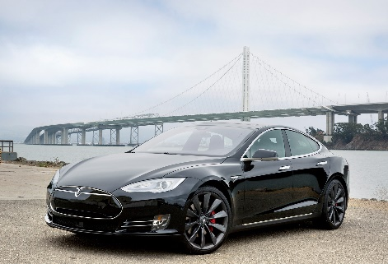 | 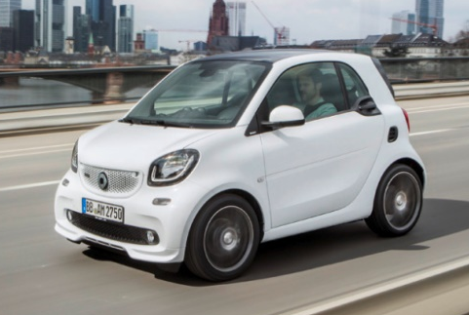
seating capacity | 5 adults | 2 adults
powertrain | - three phase, four pole AC induction motor with copper rotor  - 75 kWh or 100 kWh microprocessor controlled, lithium-ion battery | - 898-cc turbocharged three-cylinder engine
features | - smart air suspension with GPS memory  - speed sensitive electronic power steering | - performance sports suspension with specially adapted ESP®  - sports power steering  - dual-clutch transmission with Race Start function.
CO2 emissions (g/ km) | 0 | 102
acceleration 0-100 km/h (s) | 2.8 | 9.5
top speed (km/ h) | 250 | 165

ABSOLUTE PARTICIPLE CLAUSE
The participle clause and the main clause should have the same subject.
Being a brilliant engineer, Karl Benz had poor business skills.
(Both parts of the sentence are about Karl).

What about this one?
Being a brilliant engineer, his wife always supported him.
Wrong!
In this sentence, the wife appears to be a brilliant engineer, not Karl.
Karl Benz was a brilliant engineer and his wife always supported him.

What can you do in this case? You can use the Absolute participle clause and keep both subjects.
Karl Benz being a brilliant engineer, his wife always supported him. ( = As Karl Benz was a brilliant engineer, his wife always supported him.)
OR
Karl Benz was a brilliant engineer, with his wife always supporting him.
You can add WITH to the participle clause.
Do not translate the WITH into Russian.

48 Identify subjects and participles in the sentences below.
- With cars doing most or all of the driving, you will be free to make the most of your time spent in the vehicle.
- Practical moves to increase road safety in the past have made an incredible impact, with seatbelt laws and airbags reducing the annual death toll to a record low of 32,719 in 2013.
- With the recent report predicting that driverless car technology could reduce fatalities by 90 percent by the mid-century, 29,447 lives could be saved every year.

49 Transform the sentences so that they contain the Absolute participle clause.
- Because all cars will be automated, there will be less chance of accidents caused by human error.
- Because traffic congestion will also decrease, it will likely take you less time to get to your destination.
- Once autonomous vehicles go mainstream, commuters worldwide could save a combined 1 billion hours every day.
- Adaptive headlights can be a great support to road safety, as an estimated 150,000 crashes occur each year on dark curves.
- While traditional manufacturers slowly add semiautonomous features, Tesla is taking a more aggressive approach.
- If a driver brakes suddenly, the car will warn others nearby to help them avoid a collision.
- If the driver does not react to the warning, the automatic braking system immediately brings the car to a stop.
- Self-driving cars could drastically reduce the number of accidents and thousands of lives would be saved.
Module 7 Lesson 4
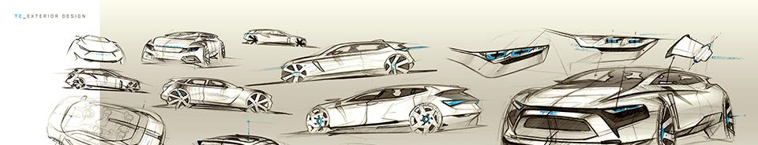
50 What will cars be like in the future? Complete the sentences with your ideas.
Cars of the future

10 years from now, cars will have …/ cars won’t have…./ cars will be able to …
100 years from now cars will have …/ cars won’t have … / cars will be able to …

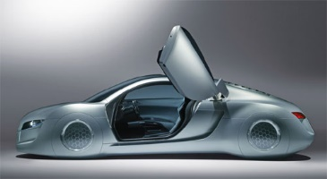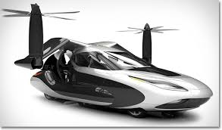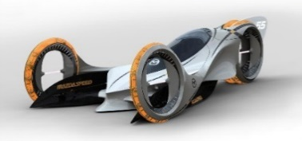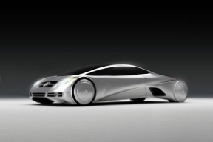

51 Listen to the audio fragment. Mark the ideas you have mentioned. Which of the speakers do you agree with?
52 What variants of the car future are presented in this text? Which do you agree with?
There are broadly two routes down which the car can wind to 2040. The first is the model we are familiar with: car ownership. There are more than 34.4m cars on British roads. It’s clear the British still love their cars. Automotive manufacturers across the globe would love nothing more than the current model of private car ownership to continue. A car parked outside every home, new models bought on registration plate changes and regular servicing at your local garage, just with the car able to drive itself there for a robot to do the work. That route could see the car transform from a vehicle into a moving personal space. Once it drives itself, there’s no need to have the traditional layout – or even to face forward.
The other road to the 2040 car is the exact opposite. Once cars are fully autonomous there’s no reason they couldn’t become a service rather than something you buy and own. Car clubs such as ZipCar already offer cars without ownership, while services such as Uber and Lyft provide on-demand transport wherever you want to go. Take the human element out of the equation and it’s not hard to envision a world populated, not by cars, but by public transport pods. (Samuel Gibbs, The Guardian)

53 Choose one of the future car trends.
Read the corresponding text and prepare its summary
In groups discuss and evaluate* these trends according to the following criteria:

 | flying cars | self-driving cars | V2V
How useful is this trend?
How cost-effective is this trend?
How viable is this trend?
*on a scale of 1 to 5

Text 1. SELF-DRIVING CARS

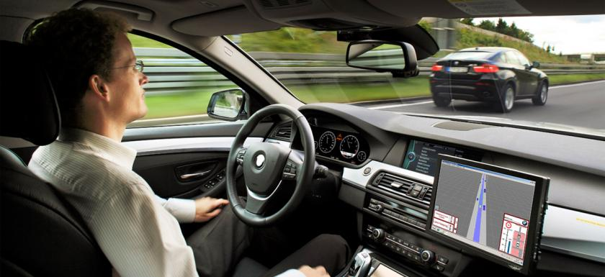
In California and Nevada, Google engineers have already tested self-driving cars on more than 200,000 miles (321,869 kilometers) of public highways and roads. Google's cars not only record images of the road, but their computerized maps view road signs, find alternative routes and see traffic lights before they are even visible to a person. By using lasers, radars and cameras, the cars can analyze and process information about their surroundings faster than a human can.
If self-driving cars do make it to mass production, we might have a little more time on our hands. Americans spend an average of 100 hours sitting in traffic every year. Cars that drive themselves would most likely have the option to engage in platooning*, where multiple cars drive very close to each and act as one unit. Some people believe platooning would decrease highway accidents because the cars would be communicating and reacting to each other simultaneously, without the on-going distractions that drivers face.
In some of Google's tests, the cars learned the details of a road by driving on it several times, and when it was time to drive itself, it was able to identify when there were pedestrians crossing and stopped to let them pass by. Self-driving cars could make transportation safer for all of us by eliminating the cause of 95 percent of today's accidents: human error.

*platoon – объединяться в колонны

54 Present the information from your text to the group.
Pay attention to the following questions:
1. What problem is this trend going to solve?
2. How far has it been developed?
3. Which car manufacturers are working on it?

Text 2. CARS THAT COMMUNICATE WITH EACH OTHER AND THE ROAD

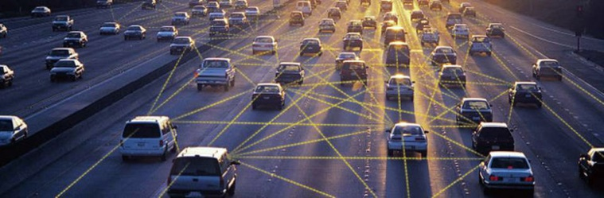
Car manufacturers are seriously looking into and researching two technologies that would enable future cars to communicate with each other and with objects around them.
Imagine approaching an intersection* as another car runs a red light. You don't see them at first, but your car gets a signal from the other car that it's directly in your path and warns you of the potential collision, or even hits the brakes automatically to avoid an accident. A developing technology called Vehicle-to-Vehicle communication, or V2V, is being tested by automotive manufacturers like Ford as a way to help reduce the amount of accidents on the road.
V2V works by using wireless signals to send information back and forth between cars about their location, speed and direction. The information is then communicated to the cars around it in order to provide information on how to keep the vehicles safe distances from each other.
But researchers aren't only considering V2V communication, vehicle-to-infrastructure communication, or V2I, is being tested as well. V2I would allow vehicles to communicate with things like road signs or traffic signals and provide information to the vehicle about safety issues. Incorporating V2I into vehicles, along with V2V systems, would reduce all target vehicle crashes by 81 percent.
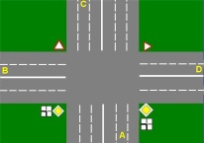
intersection

54 Present the information from your text to the group.
Pay attention to the following questions:
1. What problem is this trend going to solve?
2. How far has it been developed?
3. Which car manufacturers are working on it?

Text 3. FLYING CARS

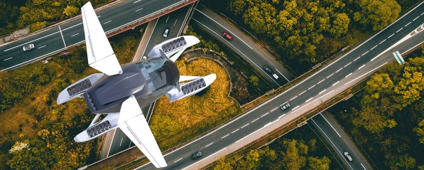
A Russian company has unveiled its futuristic flying car. Hoversurf, the firm behind the hoverbike, has unveiled the ‘Formula Project’ - a car with fold-out* wings which could help beat traffic jams. Using similar technology to its hoverbike the vertical take-off and landing (VTOL) vehicle can seat up to five people and is powered by 52 turbine propulsion units and 48 electric thrusters. The body is made up of 3D printed carbon fibre and metals, and thanks to its fold away wings, it can fit into a standard garage or parking space. Hoversurf says that the vehicle, which navigates using 3D vision technology, is "ready to use in real world”. Hoversurf adds that the vehicle is failsafe: “If the wing breaks, the copter will land. If the copter breaks, the plane will land.”

Hoversurf is not the only company attempting to make flying cars. Airbus has unveiled plans to create a vehicle which is part self-driving and part drone. The futuristic vehicle is essentially a pod that sits upon a wheeled-platform, and if, for example, the driver gets stuck in traffic, then the upper part can detach from the wheels and release its propellers, allowing it to take off. Airbus says the concept could help ease traffic congestion in the busiest cities.

Terrafugia (a Volvo-backed start up) has been working on a prototype for years featuring an in-built parachute system. The car, known as Transition, could go on the market in 2019. The hybrid-electric vehicles will have two seats, luggage storage, rear-view cameras and a built-in safety parachute system. It will be able to fly at speeds of 100 miles per hour and can reach heights of up to 10,000 feet.
*Fold-out – складной
** thruster – двигатель системы управления

50 Present the information from your text to the group.
Pay attention to the following questions:
1. What problem is this trend going to solve?
2. How far has it been developed?
3. Which car manufacturers are working on it?

CONSOLIDATION

1 Test your knowledge of the essential vocabulary by translating these word combinations into English
- Вращающиеся кресла
- Исправленная конструкция
- Набирающая скорость машина
- Отлаженный механизм
- Раздражающая особенность
- Топливосберегающее устройство

- Двигатель внутреннего сгорания
- Информационно-развлекательная передача
- Мультимедийный экран
- Плохое исполнение
- Обязательное оборудование
- Самоходное транспортное средство
- Современные технологии
- Транспортное средство, не выделяющее отработанных газов

- Избежать столкновения
- Подвергаться износу
- Предупреждать о столкновениях
- Предупреждать столкновения
- Руление при движении задним ходом
- Устранять дорожные пробки
- Переключать передачи
Этот автомобиль:
- вмещает семь пассажиров
- может похвастаться роскошным интерьером
- не выделяет в атмосферу ничего, кроме водяного пара
- оснащен винтом для движения под водой
- работает на паровой тяге
- разгоняется с 0 до 100 за 5 секунд
2 Complete the sentences using the prompts.

When making a left turn,  While driving in reverse,  When trying to parallel park,  When issued a speeding ticket,  Hearing a high-pitched noise from your brakes,  Having parked your car in the city centre,  Having bought a used car, | check …  make sure that …  don’t …

3 Put the words in order to make a sentence.
- sharing/ popular / Car/ very/ become/ recently/ has.
- a/ safety/ collision/ can/ Modern/ be/ life-/ features/ saving/ in.
- vehicle/ in/ self-/ The/ working/ created/ first/ propelled/ was/ 1672.
- turn,/ taxi/ Having/ brakes/ missed/ hit/ his/ the/ driver/ the.
- Being/ replaced/ be/ subjected/ to/ regularly/ constant/ tyres/ wear,/ the/ need/ to.
4 Write the opening and the concluding sentences of the paragraphs.

_____________ . It is believed they will dramatically reduce road accidents by eliminating human error and save millions of lives. These cars will also improve traffic and fuel efficiency. Another advantage is that they will allow you to spend the time in the car more productively. ____________ .

_______________.There is an opinion that it was the self-propelled steam-powered military tractor invented by Nicolas Joseph Cugnot in 1769. Others think it was Gottlieb Daimler's vehicle in 1885 or Karl Benz's in 1886. Some believe that this title should be given to Henry Ford, who he perfected the mass production assembly line and the car transmission mechanism. ______________.

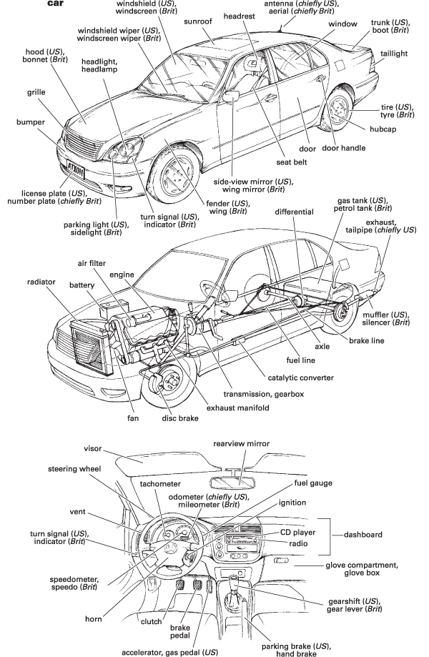
Merriam-Webster’s Learner Dictionary

alternator генератор
axle мост, ось
battery аккумулятор
brake fluid тормозная жидкость
brake pad тормозная колодка
coolant охлаждающая жидкость
convertible автомобиль типа «кабриолет»
crank коленвал
diesel engine дизельный двигатель
drive belt приводной ремень
drum тормозной барабан
fog lights противотуманные фары
four-wheel drive полноприводный
fuel injection system система впрыска топлива
fuel pump бензонасос
fuse предохранитель
gasoline engine бензиновый двигатель
hinge петля, шарнир
humvee армейский вездеход
hybrid engine гибридный двигатель
idling режим работы на холостом ходу
lemon автомобиль со скрытыми дефектами
low-rider автомобиль с низкой посадкой
luxury car автомобиль класса «люкс»
off-road vehicle вездеход
oil filter масляный фильтр
plug-in vehicle электромобиль, подзаряжаемый от розетки
powertrain силовой агрегат
race car гоночный автомобиль
ragtop/ soft-top легковой автомобиль с откидным верхом
recall отзыв (автомобилей)
rotary engine ротативный двигатель
runabout малолитражка
RV (recreation vehicle) дом на колесах
shock absorber амортизатор
spark plugs свечи зажигания
sports utility vehicle (SUV) «паркетный» внедорожник
suspension подвеска
station wagon автомобиль с кузовом типа «универсал»
stock car серийный автомобиль
stretch limo лимузин (разг.)
subcompact малогабаритный двухдверный автомобиль
torque крутящий момент
valve клапан
van фургон

Running at a slow speed or out of gear

